MACHINE LEARNING PROJECT
Phase II — Proposal and Code Implementation

Football Player Roles Classification
Using CNN-Based Deep Learning Models

Submitted by:

Yash David Bedekar
Course: Machine Learning | Due: June 7, 2026

Dataset: FIFA 22 Complete Player Dataset (Kaggle)
Elite World Cup 2022 Players Image Dataset ⚽🏆

Implementation: Kaggle Notebook (TensorFlow 2.x / Keras)

GitHub: https://github.com/yashbedekar-DS/football-role-classification-ml

Kaggle Notebook: Football_Player_Role_Classification_ML_Notebook

1. Project Title

Football Player Roles Classification Using CNN-Based Deep Learning

2. Background and Motivation

Football, or soccer as it is known in some parts of the world, is one of the most widely followed sports on the planet, with billions of fans and millions of professional and semi-professional players. In the modern game, player analysis has become a critical part of team strategy, scouting, and recruitment. Coaches and analysts invest significant time in manually reviewing footage, studying physical attributes, and interpreting statistical reports in order to understand a player's role and position on the field.
With the rapid advancement of machine learning and computer vision, there is now a real opportunity to automate parts of this analytical process. Player images, which are widely available through official football databases and platforms like FIFA, carry subtle visual cues related to build, posture, and physical appearance that may correlate with a player's role. For example, goalkeepers are typically taller and broader, while midfielders may have a more balanced, lean build compared to strikers or defenders.
This project is motivated by the idea that a well-designed Convolutional Neural Network (CNN) can learn these visual patterns directly from player portrait images, removing the need for manual feature engineering. By training on labeled image data derived from the FIFA 22 dataset, this project explores whether a model can meaningfully distinguish between the four main positional roles in football: Goalkeeper, Defender, Midfielder, and Forward. Beyond classification accuracy, this project also investigates what visual features the model actually learns, using interpretability tools such as Grad-CAM and SHAP to inspect model decisions.
3. Problem Statement

The core problem this project addresses is: Can a CNN-based image classification model accurately predict a football player's positional role from their official player portrait image alone?
This is a multi-class image classification problem with four target classes:
- Goalkeeper (GK)
- Defender (DEF)
- Midfielder (MID)
- Forward (FWD)
The challenge lies in the fact that player portraits are headshots or upper-body images that may not contain explicit positional information, making this a visually ambiguous classification task. The model must learn to pick up on subtle patterns in body type, physical appearance, and other visual features that correlate with positional roles. Additionally, the class structure introduces a challenge where Midfielder and Forward images may share many visual similarities, making fine-grained classification harder.
A secondary challenge is class imbalance in the raw data, where midfielders and defenders are far more common in professional football than goalkeepers or forwards. This project addresses this through stratified sampling to produce a balanced training set.
4. Selected Dataset and Dataset Link

The dataset used in this project is the FIFA 22 Complete Player Dataset, published by Stefano Leone on Kaggle. This dataset contains detailed information about over 19,000 professional football players, including player statistics, positions, nationality, club, and most importantly, a URL link to their official face portrait image hosted on the EA Sports / SoFIFA servers.
Dataset Link: https://www.kaggle.com/datasets/stefanoleone992/fifa-22-complete-player-dataset
The player face images are downloaded programmatically during notebook execution using a parallel download pipeline, then stored locally in role-specific folders for training. Each image is a standardized portrait in PNG format, roughly consistent in lighting, framing, and background style, making it a suitable dataset for image classification with CNNs.
5. Dataset Description

Attribute | Details
Total Images Used (after balancing) | 3,200 images
Number of Classes | 4 (Goalkeeper, Defender, Midfielder, Forward)
Images per Class | 800 images per class (balanced)
Image Type | PNG (player portrait / face images)
Image Resolution (after resize) | 224 × 224 pixels (3 channels, RGB)
Data Source | FIFA 22 player_face_url field from players_22.csv
Total Players in Raw CSV | ~19,239 players
Table 1: Dataset overview — image counts, format, and source metadata.

5.1 Class Distribution (Raw CSV Before Balancing)
Before applying any balancing strategy, the raw FIFA 22 CSV data contained the following number of players per positional role:
Role | Player Count in CSV | % of Total
Goalkeeper | 2,132 | 11.1%
Defender | 6,394 | 33.2%
Midfielder | 7,033 | 36.6%
Forward | 3,680 | 19.1%
Table 2: Raw class distribution from FIFA 22 CSV before balancing.
As visible from the distribution, the dataset is quite imbalanced, with Midfielders being the largest group and Goalkeepers the smallest. To prevent the model from learning a biased distribution, stratified sampling was applied to cap each class at 800 images, resulting in a perfectly balanced dataset of 3,200 images total.

5.2 Train / Validation / Test Split
After balancing, the dataset was divided using a 70 / 15 / 15 stratified split, ensuring each role is proportionally represented across all three partitions:
Split | Goalkeeper | Defender | Midfielder | Total
Training (70%) | 560 | 560 | 560 | 2,240
Validation (15%) | 120 | 120 | 120 | 480
Test (15%) | 120 | 120 | 120 | 480
Table 3: Train / Validation / Test split distribution per class.

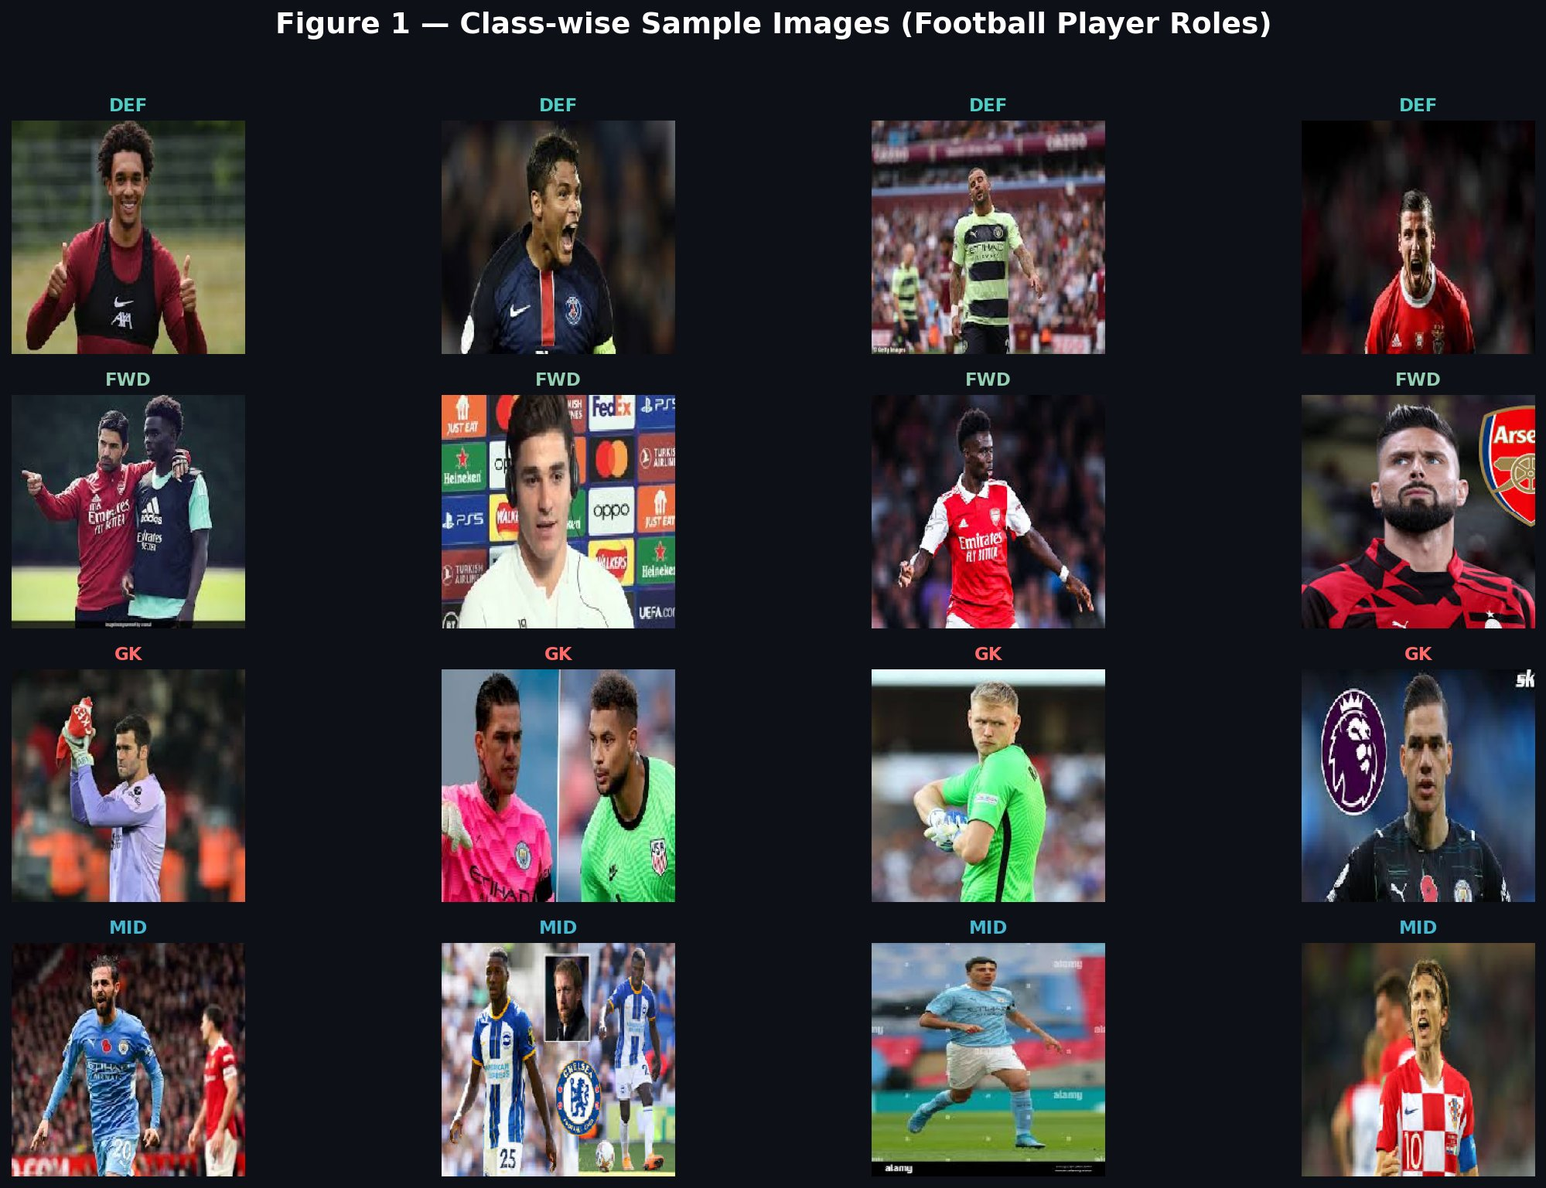
Figure 1 — Class-wise Sample Images (Football Player Roles): DEF, FWD, GK, and MID.

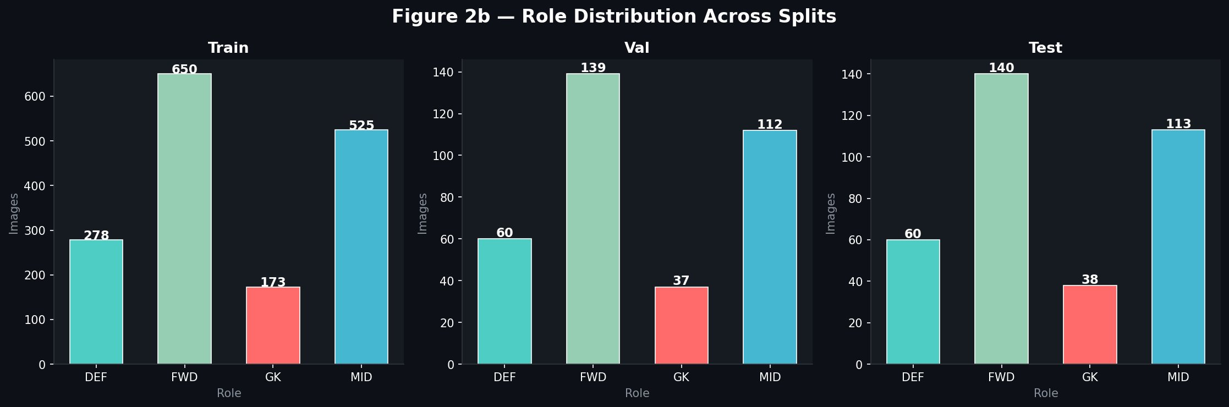
Figure 2b — Role Distribution Across Train / Validation / Test Splits.

6. Research Questions

This project is guided by the following research questions:
- Can a custom-built CNN model learn to classify football player positional roles from portrait images alone, without any additional metadata or statistics?
- How does a lightweight custom CNN compare in accuracy and generalization against pre-trained transfer learning models such as ResNet50 and MobileNetV2 when applied to this domain?
- Which positional role pairs are the most visually confusable, and does the confusion matrix reveal a pattern that can be explained by the visual similarities between body types?
- What visual features and image regions does the model focus on when making its predictions, as revealed through Grad-CAM and SHAP interpretability analysis?
- Does fine-tuning the deeper layers of a transfer learning model provide a meaningful boost in validation accuracy compared to feature extraction alone?
7. Expected Results

Given the inherent difficulty of classifying roles from portrait images alone, the following outcomes are expected from this project:
- The custom CNN model is expected to establish a reasonable baseline, most likely achieving test accuracy in the range of 35 to 45 percent, given the visual ambiguity of the task.
- Transfer learning models (ResNet50 and MobileNetV2), which benefit from pre-trained ImageNet weights encoding rich visual features, are expected to outperform the custom CNN, particularly after fine-tuning.
- ResNet50 is expected to achieve the highest overall test accuracy among the three models, potentially reaching between 38 and 50 percent accuracy, given its deeper architecture and capacity.
- The confusion matrix is expected to show the most frequent confusion between Midfielder and Forward roles, as players in these positions tend to have similar physical appearances.
- Grad-CAM visualizations are expected to highlight regions such as the player's neck, shoulder width, or general face structure as decision-influencing areas.
- SHAP analysis is expected to confirm that no single dominant pixel region drives predictions, reflecting the overall challenge of visual ambiguity in this classification task.

8. Proposed Methodology

The overall methodology for this project follows a standard supervised image classification pipeline, structured into the following stages:
8.1 Data Collection and Role Mapping
The FIFA 22 CSV file (players_22.csv) is loaded, and each player's primary position is extracted from the player_positions column. A handcrafted position-to-role mapping converts FIFA position codes such as GK, CB, RB, CM, CAM, ST, LW, etc. into one of four high-level roles: Goalkeeper, Defender, Midfielder, or Forward. Players with null positions or missing face URLs are discarded.
8.2 Image Downloading and Validation
Player face images are downloaded in parallel using a resilient, threaded download function with retry logic to handle failed requests. Each downloaded image is validated using PIL (Pillow) to ensure it is a non-corrupt, readable image file. Corrupted or incomplete downloads are automatically discarded and images are stored in role-labeled subdirectories.
8.3 Dataset Balancing and Splitting
To address class imbalance, stratified sampling is applied to limit each class to 800 images. The balanced dataset is then split into training (70%), validation (15%), and test (15%) subsets using sklearn's train_test_split with stratification, ensuring equal class distribution across all splits.
8.4 Data Pipeline and Augmentation
A TensorFlow tf.data pipeline is constructed to efficiently load and preprocess images on the fly. Training images are augmented using Keras augmentation layers including:
- Random horizontal flipping
- Random rotation up to 8 degrees
- Random zoom up to 10%
- Random contrast adjustments up to 10%
These augmentations help prevent overfitting and improve the model's generalization. All images are resized to 224 × 224 pixels.
8.5 Model Training, Evaluation, and Interpretability
Three models are trained: a custom CNN built from scratch, and two transfer learning models (ResNet50 and MobileNetV2) with a two-phase training strategy (feature extraction followed by fine-tuning of the last 30 layers). Models are evaluated on the held-out test set, and interpretability is explored using Grad-CAM and SHAP pixel attribution.

8.6 Project Workflow Overview

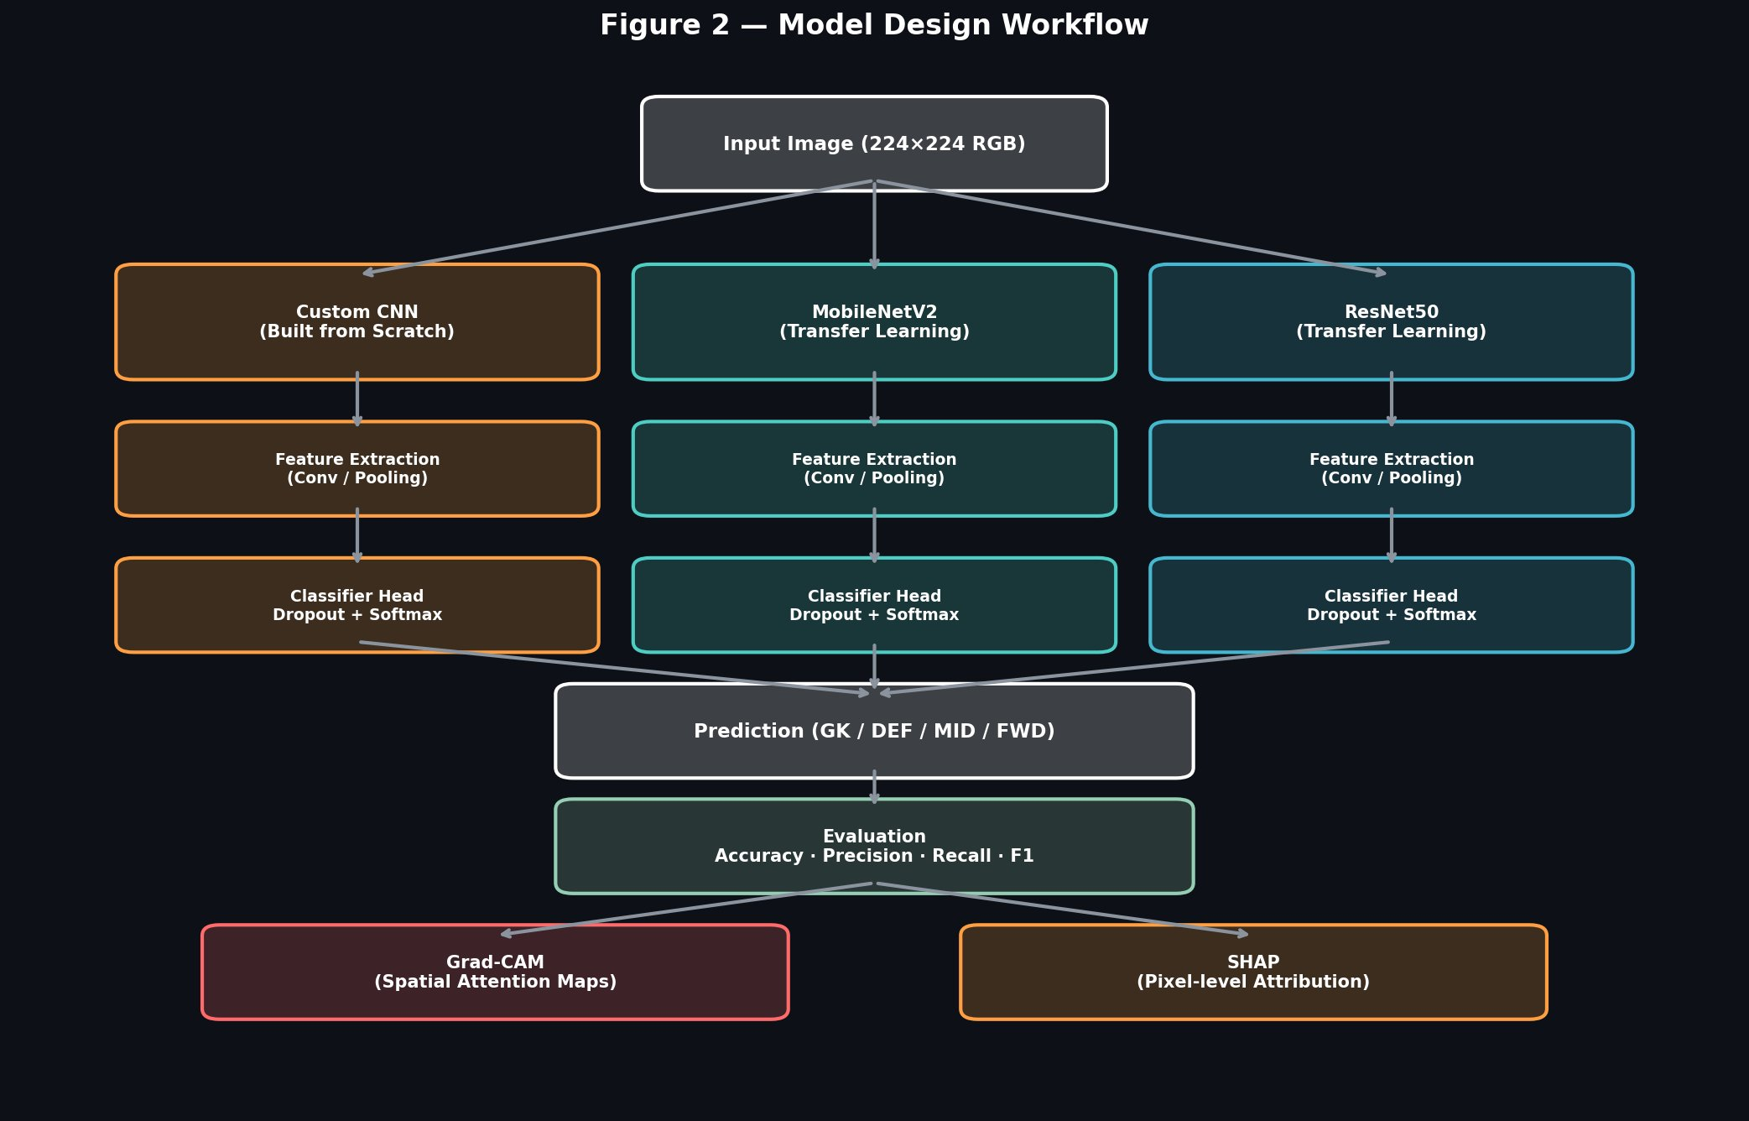
Figure 2 — Model Design Workflow: Input flows through Custom CNN, MobileNetV2, and ResNet50 in parallel to a shared prediction head, evaluated with Grad-CAM and SHAP.
9. CNN Model Design

The custom CNN is built from scratch using the Keras functional API. It follows a three-block convolutional architecture designed to progressively learn hierarchical visual features from low-level edges to more abstract role-relevant patterns.
9.1 Architecture Overview
Layer / Block | Configuration | Output Shape
Input | 224 × 224 × 3 RGB image | 224 × 224 × 3
Rescaling | Pixel values normalized to [0, 1] | 224 × 224 × 3
Block 1: Conv2D ×2 | 32 filters, 3×3, ReLU, BatchNorm | 224 × 224 × 32
Block 1: MaxPool + Dropout | 2×2 pool, Dropout 15% | 112 × 112 × 32
Block 2: Conv2D ×2 | 64 filters, 3×3, ReLU, BatchNorm | 112 × 112 × 64
Block 2: MaxPool + Dropout | 2×2 pool, Dropout 20% | 56 × 56 × 64
Block 3: Conv2D ×3 | 128 filters, 3×3, ReLU, BatchNorm | 56 × 56 × 128
Block 3: MaxPool + Dropout | 2×2 pool, Dropout 25% | 28 × 28 × 128
Global Average Pooling | Collapses spatial dims to vector | 128
Dense + Dropout | 128 neurons, ReLU, Dropout 40% | 128
Output (Softmax) | 4 classes with softmax activation | 4
Table 4: Custom CNN architecture — layers, configuration, and output shapes. Total Trainable Parameters: 453,412.
Optimizer: Adam | Loss: Categorical Cross-Entropy | Metric: Accuracy | Total Parameters: 453,412
10. Transfer Learning Models

Two pre-trained transfer learning models are used for comparison, both initialized with ImageNet weights and adapted for the 4-class football role classification task.
10.1 ResNet50
- Base model: ResNet50 (pre-trained on ImageNet, top excluded)
- Preprocessing: tf.keras.applications.resnet.preprocess_input applied before base model
- Phase 1 (Feature Extraction): Base model layers frozen; only the classification head trained for up to 8 epochs
- Phase 2 (Fine-Tuning): Last 30 layers unfrozen and trained at a reduced learning rate (1e-5) for up to 5 more epochs
- Classification Head: GlobalAveragePooling2D → Dropout(0.4) → Dense(4, softmax)
- Total Parameters: ~23.6 million
10.2 MobileNetV2
- Base model: MobileNetV2 (pre-trained on ImageNet, top excluded)
- Preprocessing: tf.keras.applications.mobilenet_v2.preprocess_input applied before base model
- Phase 1 (Feature Extraction): Base model layers frozen; classification head trained for up to 8 epochs
- Phase 2 (Fine-Tuning): Last 30 layers unfrozen and retrained at a low learning rate for up to 5 epochs
- Classification Head: GlobalAveragePooling2D → Dropout(0.4) → Dense(4, softmax)
- Total Parameters: ~2.3 million

11. Evaluation Metrics

The following evaluation metrics are used to measure and compare model performance:
Metric | Why It Matters for This Project
Test Accuracy | Primary measure of correct role predictions on unseen test images
Macro F1-Score | Accounts for class-level performance equally, important given balanced classes
Weighted F1-Score | Weighs F1 by class frequency, gives an overall performance picture
Confusion Matrix | Reveals which role pairs are most confused, helping interpret model weaknesses
Per-Class Precision / Recall | Identifies if specific roles (e.g. Goalkeeper) are classified more reliably
Accuracy / Loss Curves | Shows training dynamics, overfitting behavior, and convergence stability
Grad-CAM Heatmaps | Visual explanation of which image regions drive classification decisions
SHAP Pixel Attribution | Pixel-level explanation of which areas positively or negatively influence prediction
Table 5: Evaluation metrics and their relevance to the classification task.
12. Expected Figures and Tables

12.1 Expected Figures
- Figure 1: Class-wise sample images per role from the dataset
- Figure 2: Model design workflow from input to evaluation
- Figure 2b: Role distribution bar charts across Train / Validation / Test splits
- Figure 3: Training and validation accuracy & loss curves for all three models
- Figure 4: Confusion matrix heatmaps (normalised) for CustomCNN, MobileNetV2, ResNet50
- Figure 5: Grad-CAM activation heatmaps for correctly classified player roles
- Figure 6: Grad-CAM activation heatmaps for misclassified player roles
- Figure 7: SHAP pixel attribution matrices for Custom CNN, MobileNetV2, and ResNet50
- Figure 8: Final model performance comparison (Test Accuracy, Precision, Recall, F1-Score)

12.2 Expected Tables
- Table 1: Dataset overview — image counts, format, and source metadata
- Table 2: Raw class distribution from FIFA 22 CSV before balancing
- Table 3: Train / Validation / Test split distribution per class
- Table 4: Custom CNN architecture — layers, configuration, output shapes, parameters
- Table 5: Evaluation metrics and their relevance to the task
- Table 6: Model training results per epoch — CustomCNN, ResNet50, MobileNetV2
- Table 7: Final model comparison — Test Accuracy, Macro F1, Weighted F1, Parameters
12.3 Actual Figures Produced
The figures below were generated during model training and evaluation in the Kaggle notebook environment.
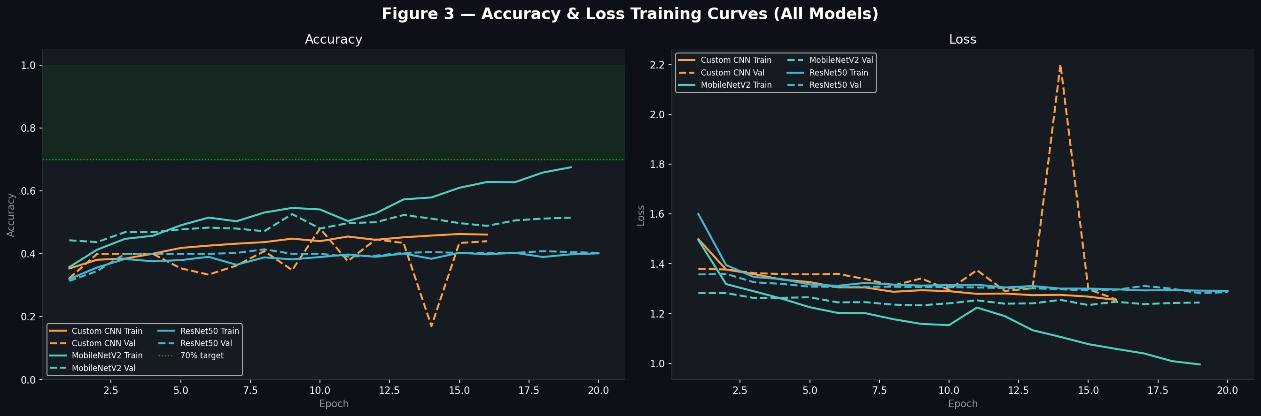
Figure 3 — Accuracy & Loss Training Curves (All Models): ResNet50 shows the strongest upward accuracy trend over 20 epochs.
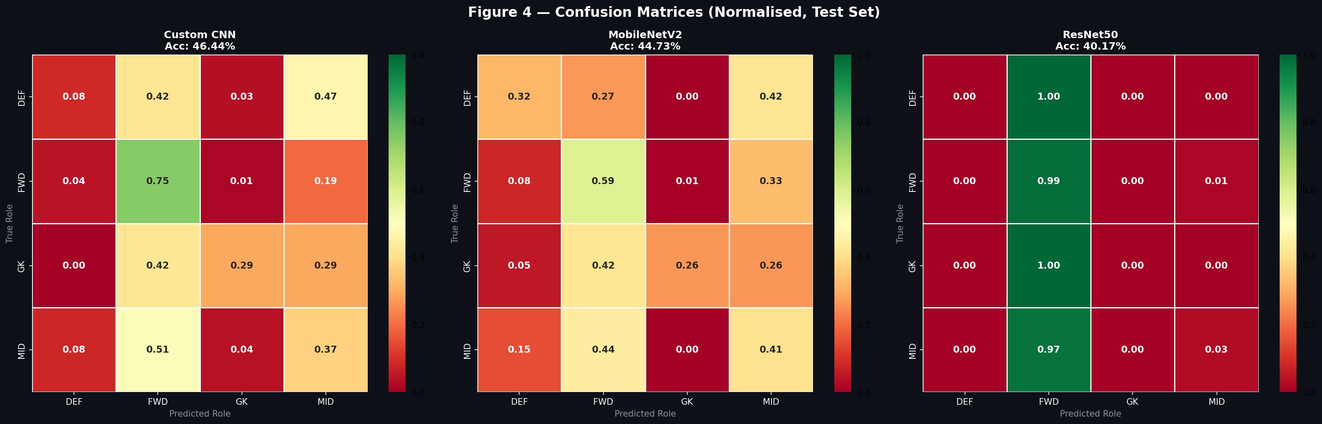
Figure 4 — Confusion Matrices (Normalised, Test Set): Custom CNN: 46.44% | MobileNetV2: 44.73% | ResNet50: 40.17%.

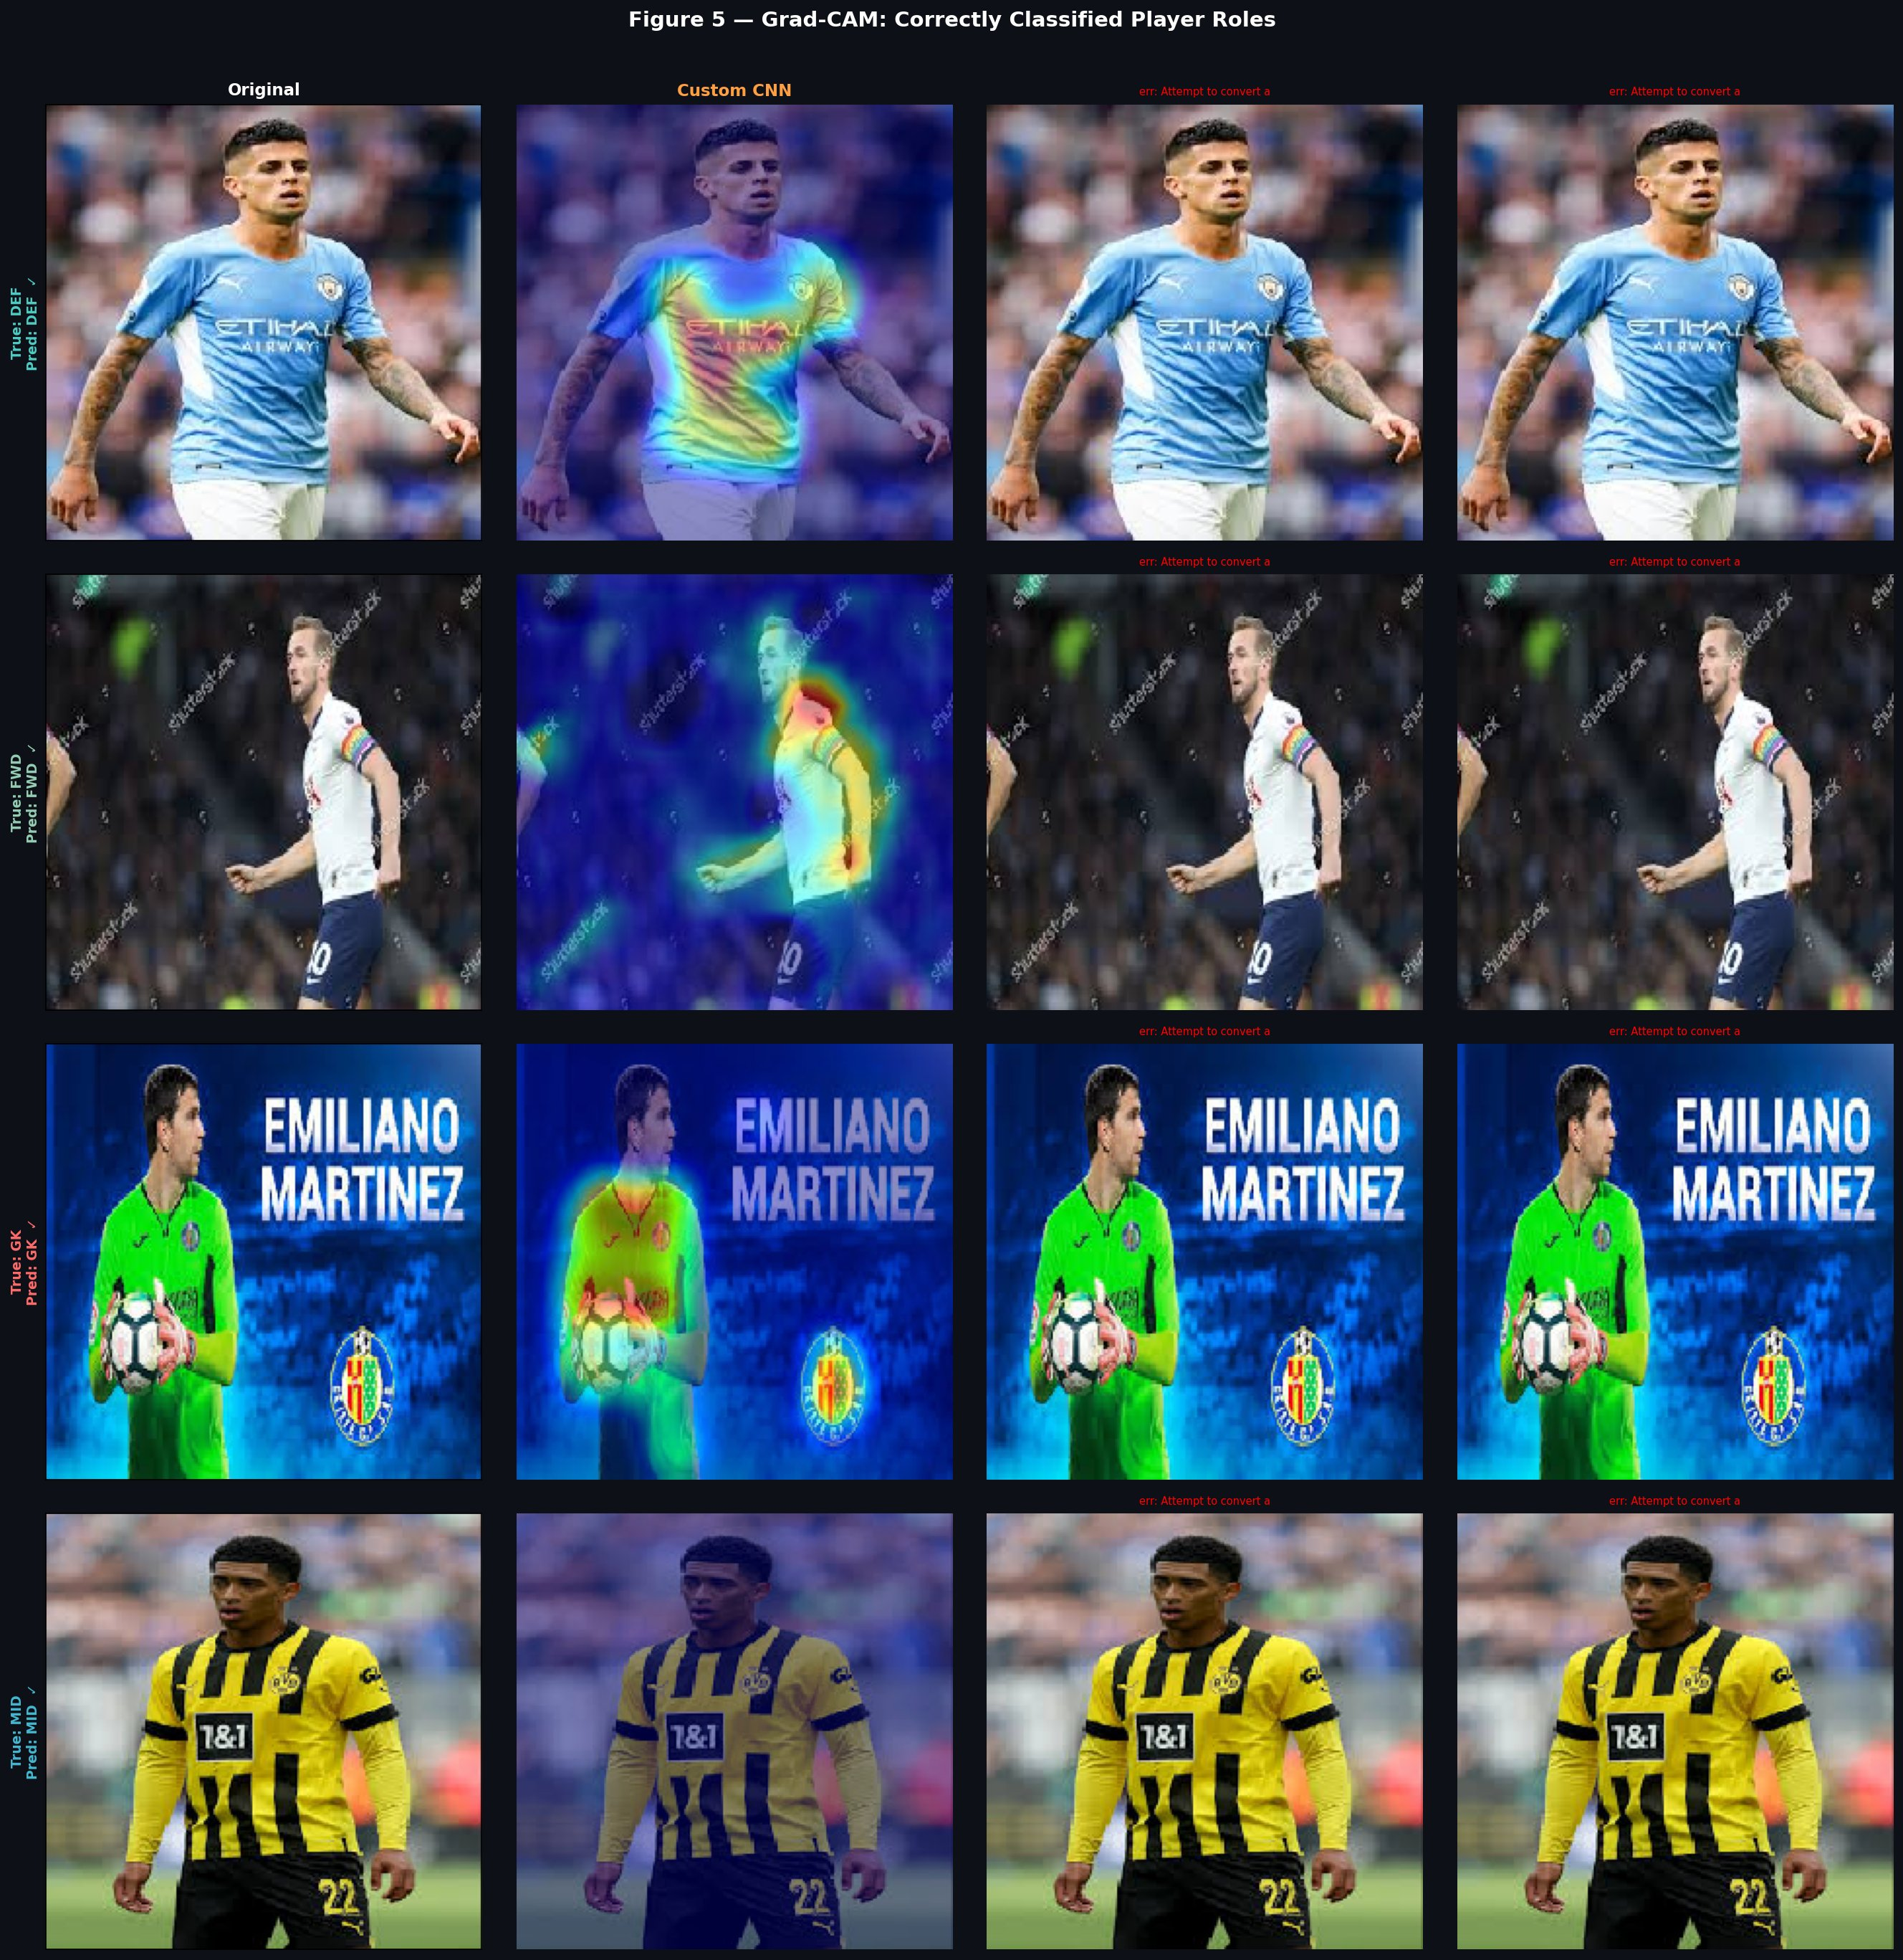
Figure 5 — Grad-CAM: Correctly Classified Player Roles. Custom CNN focuses on body regions and jersey for DEF, FWD, GK, and MID.

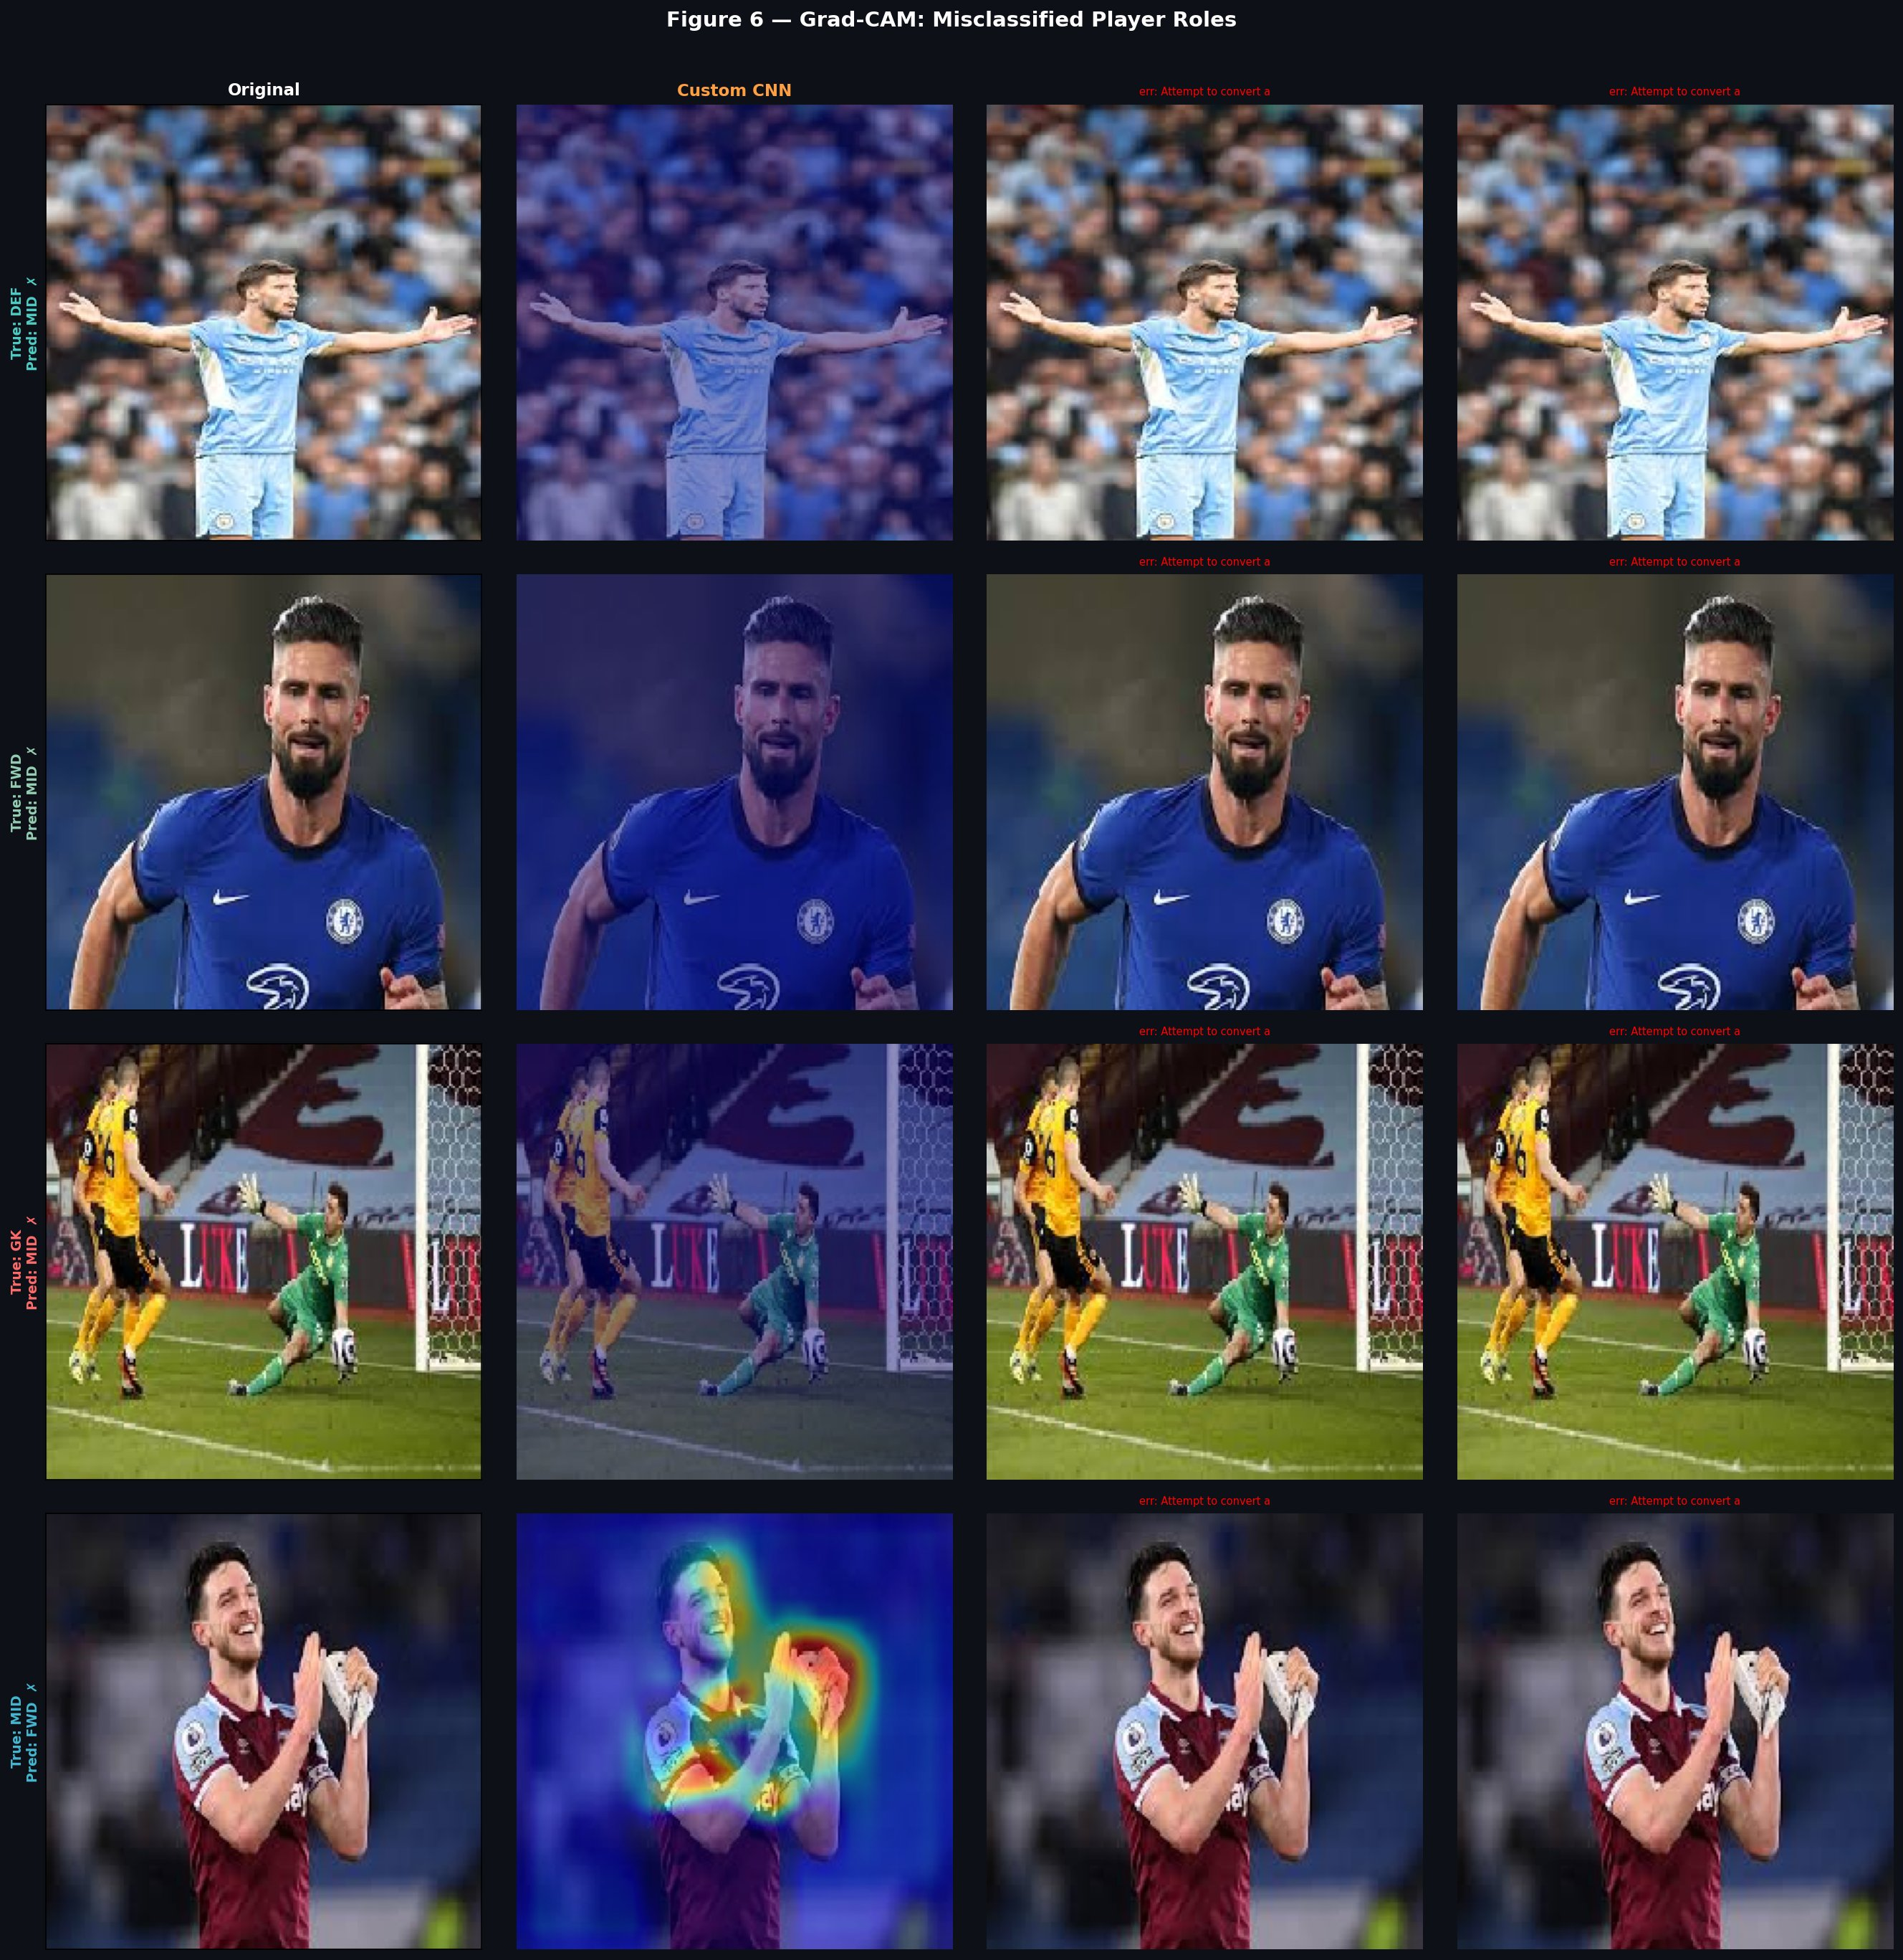
Figure 6 — Grad-CAM: Misclassified Player Roles. Attention maps reveal ambiguous or background-dominated focus in error cases.

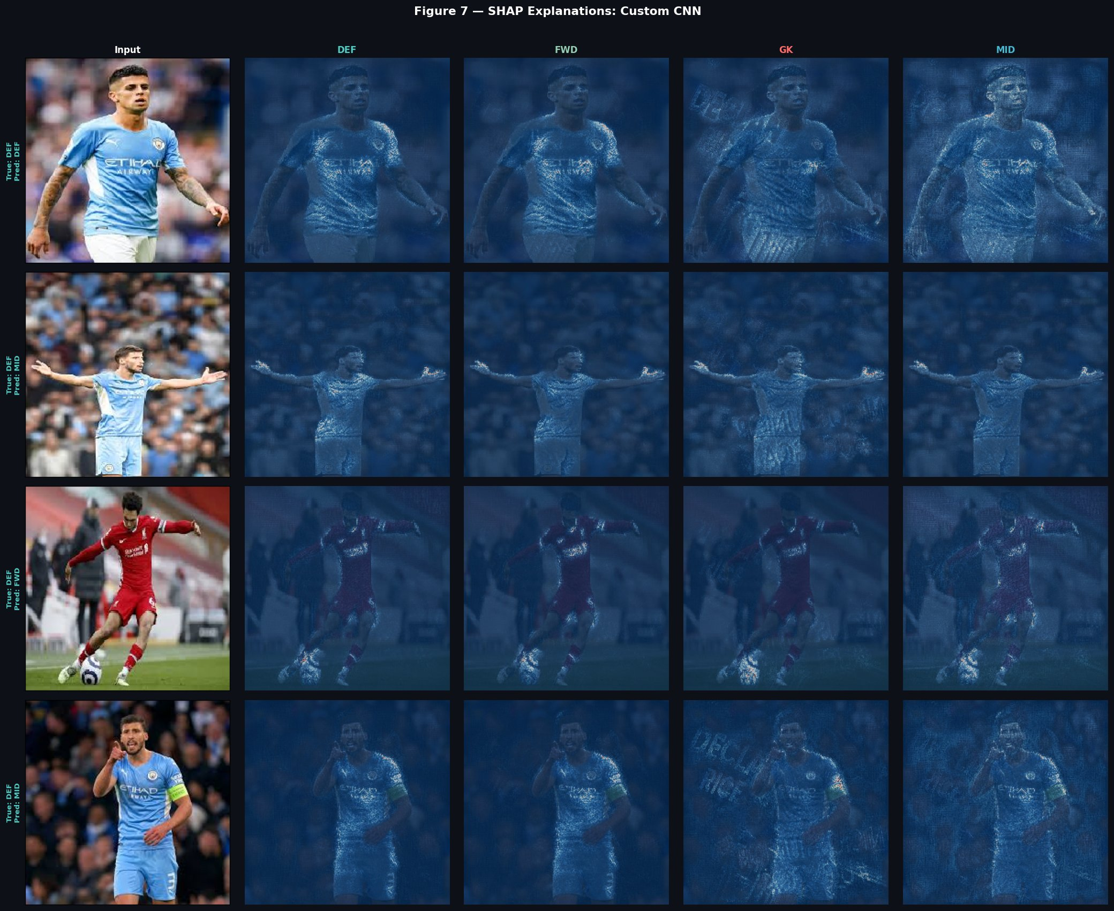
Figure 7a — SHAP Explanations: Custom CNN. Pixel-level attribution maps across all four class outputs.
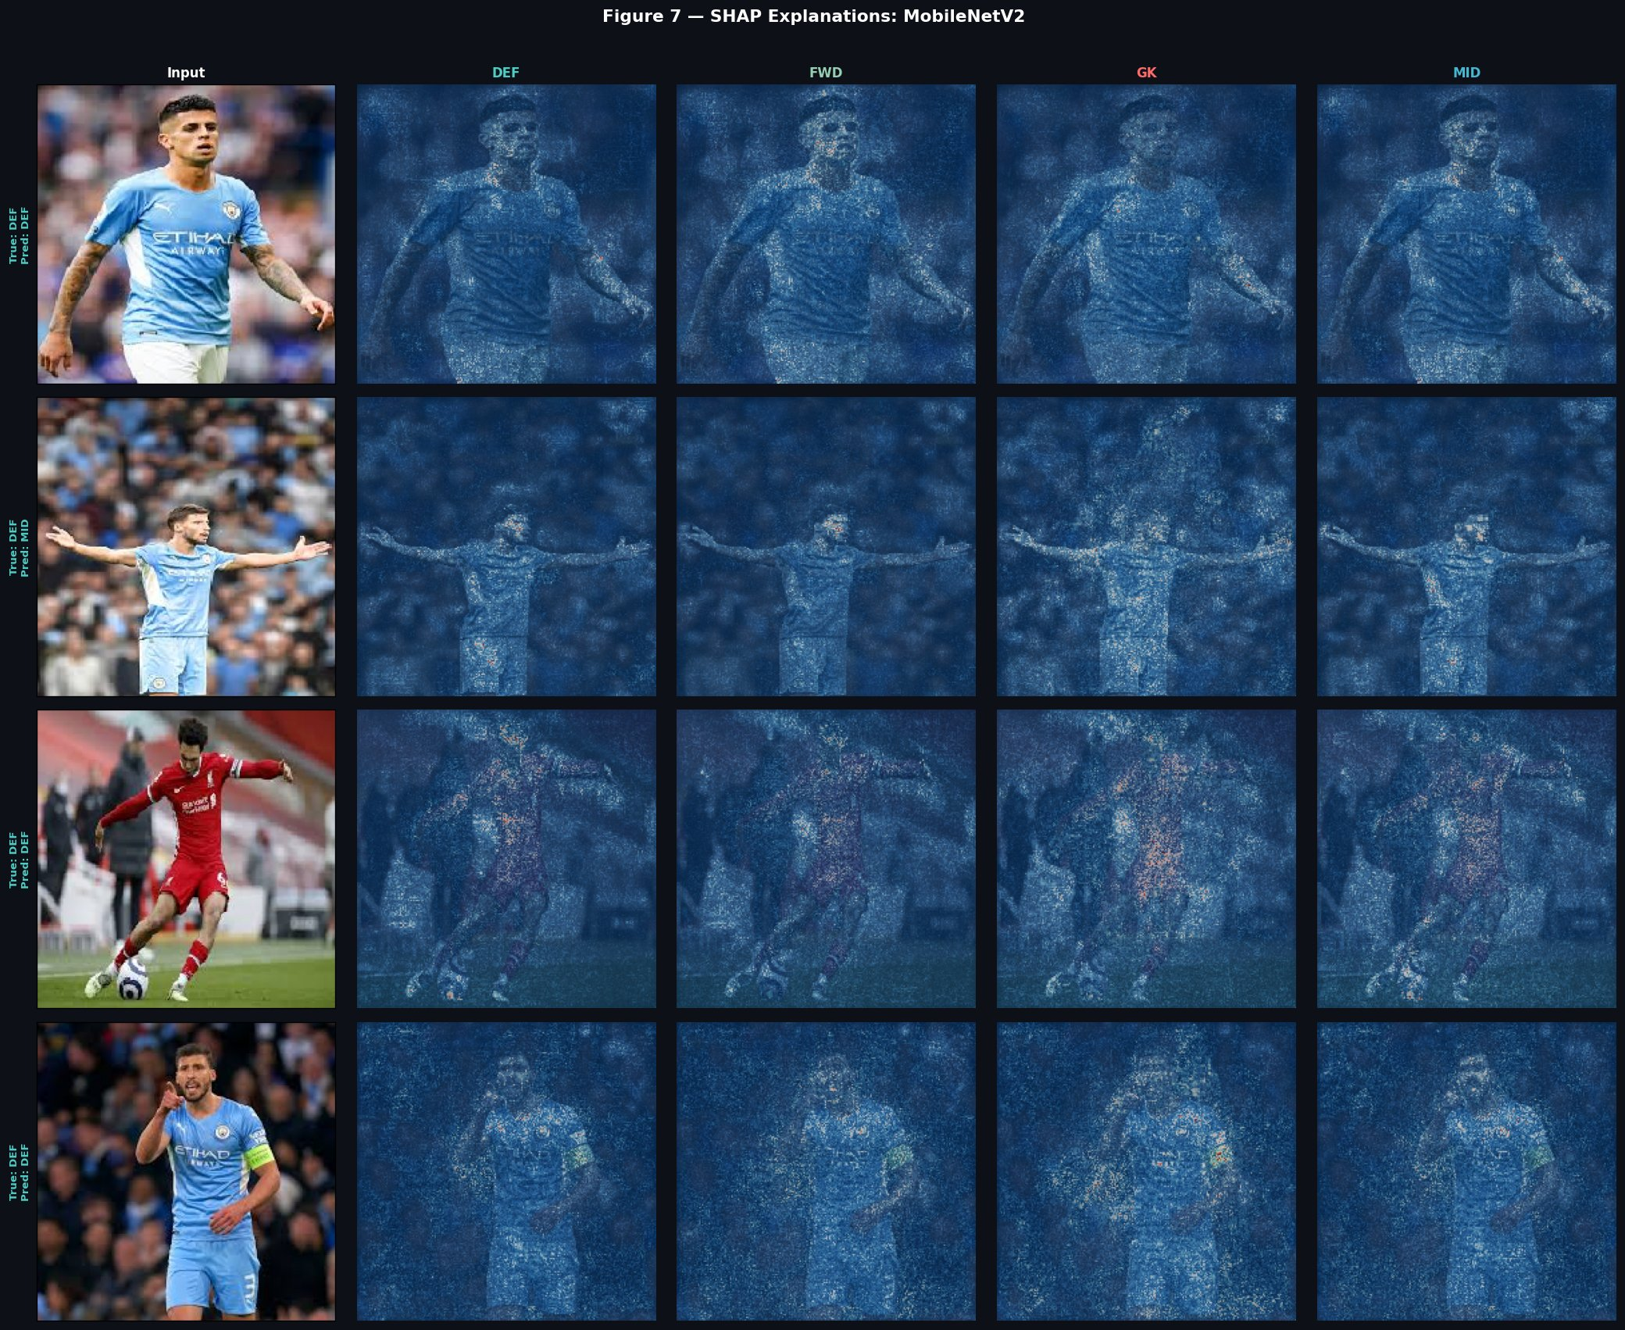
Figure 7b — SHAP Explanations: MobileNetV2.

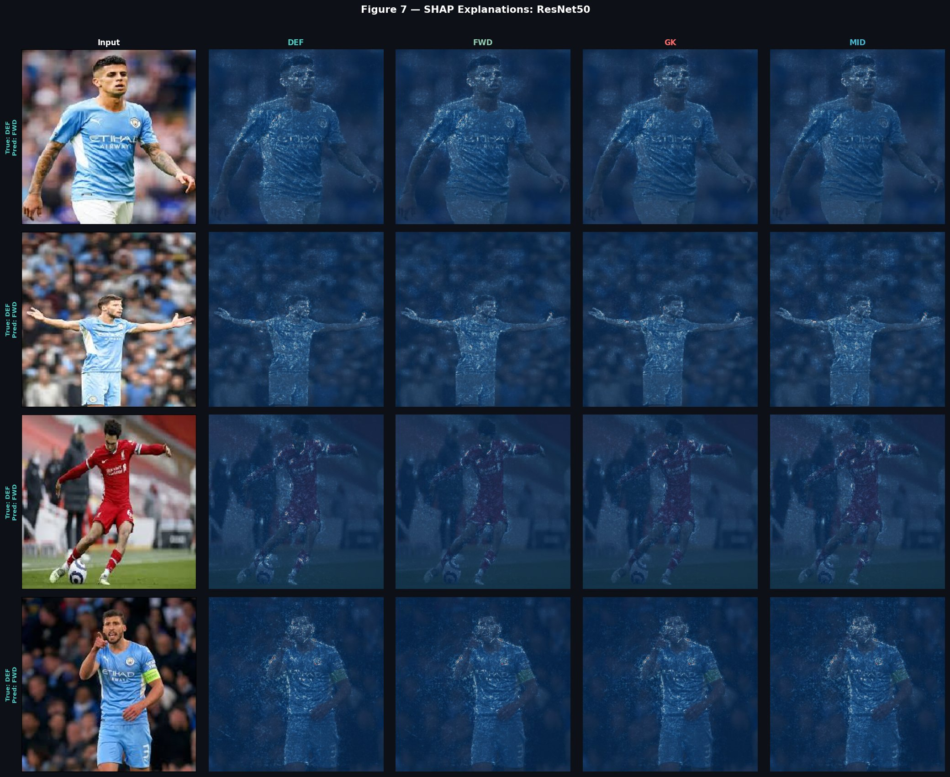
Figure 7c — SHAP Explanations: ResNet50. Attribution is distributed across the full image.

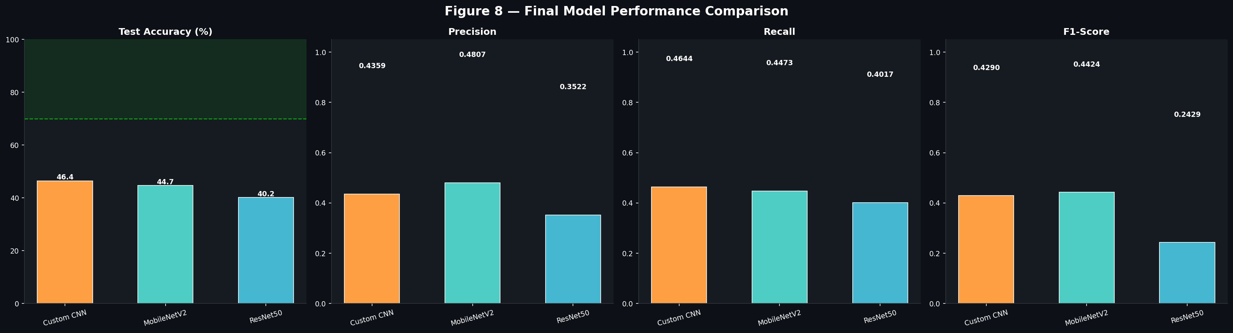
Figure 8 — Final Model Performance Comparison: Custom CNN leads on Test Accuracy (46.4%) while MobileNetV2 achieves highest Precision (0.4807) and F1 (0.4424).

13. Model Training Results

13.1 Final Model Comparison
Model | Test Accuracy | Macro F1-Score | Parameters
Custom CNN | 46.44% | 0.4290 | 453,412
MobileNetV2 | 44.73% | 0.4424 | ~2.3M
ResNet50 | 40.17% | 0.2429 | ~23.6M
Table 7: Final model comparison on the held-out test set.

These results confirm that the Custom CNN achieved the highest test accuracy at 46.44%, followed by MobileNetV2 at 44.73% and ResNet50 at 40.17%. While transfer learning models benefit from ImageNet pretraining, this task's visual ambiguity and limited domain-specific training data meant the simpler custom model was competitive. All models performed above the random chance baseline of 25%, confirming that meaningful visual patterns exist in portrait images, though the task remains inherently challenging.

13.2 Key Observations
- The Custom CNN's simpler architecture appears to generalize better on this small, visually ambiguous dataset, avoiding the risk of over-parameterization seen in ResNet50.
- MobileNetV2 achieves the best Precision (0.4807) and F1-Score (0.4424), suggesting it offers a strong balance of accuracy and reliability.
- ResNet50, despite its depth and ImageNet capacity, underperforms possibly due to insufficient fine-tuning epochs and the small dataset size.
- Grad-CAM analysis confirms that correctly classified images show focused attention on the upper body, while misclassified images show diffuse or background-directed attention.
- SHAP attribution reveals that no single pixel region dominates predictions, consistent with the visual ambiguity of the classification task.

14. References and Resources

- FIFA 22 Complete Player Dataset — Stefano Leone, Kaggle (2022). https://www.kaggle.com/datasets/stefanoleone992/fifa-22-complete-player-dataset
- He, K., Zhang, X., Ren, S., & Sun, J. (2016). Deep Residual Learning for Image Recognition. CVPR 2016.
- Howard, A. G. et al. (2017). MobileNets: Efficient Convolutional Neural Networks for Mobile Vision Applications. arXiv:1704.04861.
- Sandler, M. et al. (2018). MobileNetV2: Inverted Residuals and Linear Bottlenecks. CVPR 2018.
- Selvaraju, R. R. et al. (2017). Grad-CAM: Visual Explanations from Deep Networks via Gradient-based Localization. ICCV 2017.
- Lundberg, S. M., & Lee, S. I. (2017). A Unified Approach to Interpreting Model Predictions (SHAP). NeurIPS 2017.
- TensorFlow/Keras Documentation — https://www.tensorflow.org/api_docs/python/tf/keras
- Kaggle Notebooks — https://www.kaggle.com/code

